MODULE 1,2,3

Q. 1 Which of these is not a voice component of IP telephony network

Option 1 IP Phones

Option 2 Switches

Option 3 Voice Gateway

**Option 4 SDN**

Q. 2 SNMP stands for …...............................

Option 1 Simple Network Mail Protocol

Option 2 Standard Network Management Protocol

**Option 3 Simple Network Management Protocol**

Option 4 Simple Network Messaging Protocol

Q. 3 ............................... protocol enables you to discover cisco devices in network

Option 1 RIP

**Option 2 CDP**

Option 3 BGP

Option 4 SNMP

Q. 4 …............................... IDS performs packet level filtering

Option 1 Host

Option 2 Agent

**Option 3 Network**

Option 4 Packet

Q. 5 Which factor needs to be considered while deciding on the types of switch ?

Option 1 Manufacturer

**Option 2 Size of Network Segment -** confirmed

Option 3 Layer

Option 4 Interfaces

Q. 6 Which of these is not a SNMP Message type?

Option 1 Get Request

Option 2 Trap

Option 3 Set Request

**Option 4 Set Last Request**

Q. 7 MIB objects are grouped into …...............

Option 1 Graph

**Option 2 Tree**

Option 3 Clusters

Option 4 Groups

Q. 8 NetFlow Accounting does not perform …...............

**Option 1 Data Filtering - Confirmed**

Option 2 Data Export

Option 3 Data Switching

Option 4 Data Aggregation

Q. 9 Syslog level 0 is …................

Option 1 Alert

Option 2 Critical

Option 3 Error

**Option 4 Emergency**

Q. 10 Data link layer switching forwards frames based on

Option 1 IP Address

**Option 2 MAC Address**

Option 3 Port Address

Option 4 Network Address

Q. 11 Which protocol supports First Hop Redundancy

Option 1 VRRP

Option 2 HSRP

Option 3 GLBP

**Option 4 All of the above**

Q. 12 Triangle Redundancy has …............ convergence than Square Redundancy

**Option 1 Faster - confirmed**

Option 2 Slower

Option 3 Very fast

Option 4 Very slow

<https://www.ccexpert.us/network-design/building-distribution-layer-design-considerations.html>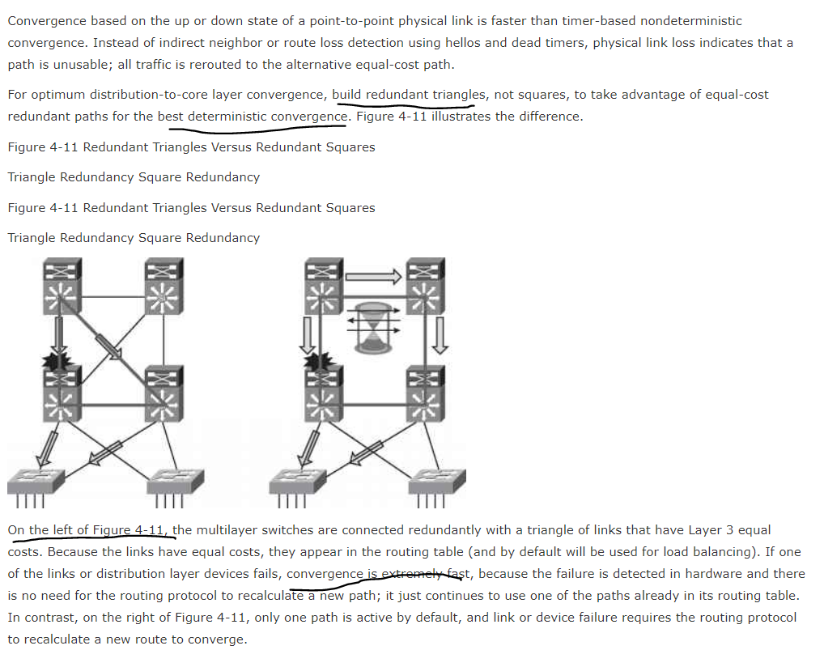

Q. 13 There has been a paradigm shift from server centric to …....................... Data Center that we use today

**Option 1 Service Centric (right pg 109 of ques10) - Confirmed**

Option 2 Application Silos

Option 3 Blade based

Option 4 SAN based

Q. 14 Which services are offered by SONA framework

Option 1 Security services

Option 2 Storage services

Option 3 Voice and Collaboration services

**Option 4 All of the above**

Q. 15 Which of these is not a parameter for performance evaluation

Option 1 CPU usage

Option 2 Availability

Option 3 Power

**Option 4 High Storage - confirmed**

Q. 16 Which of these is not a layer of the hierarchical network design

Option 1 Access

Option 2 Core

**Option 3 Presentation**

Option 4 Distribution

Q. 17 One of the ways to make network redundant are using

**Option 1 Full mesh (confirmed)**

Option 2 VOIP

Option 3 PSTN

Option 4 Frame Relay

Q. 18 RSTP stands for ….....................................

Option 1 Routing Shortest Tree Protocol

Option 2 Route Spanning Tree Protocol

**Option 3 Rapid Spanning Tree Protocol**

Option 4 Rapid Shortest Tree Protocol

Q. 19 InfiniBand connections is used at which layer

Option 1 Interactive services layer

Option 2 Management layer

**Option 3 Network Infrastructure layer**

Option 4 Application layer

Q. 20 Trap message sends a ........................

**Option 1 Alarm**

Option 2 Retrieves the next MIB value

Option 3 Modifies MIB

Option 4 Contains requested value

Q. 21 Which of these is not a function of RMON1

Option 1 Network Collisions

Option 2 Traffic congestion

Option 3 Network diagnosis

**Option 4 Mail Transfer - confirmed**

Q. 22 Syslog messages contain levels and ….........................

Option 1 Usernames

Option 2 Agents

Option 3 Autonomous Systems

**Option 4 Facilities**

Q. 23 Which rule should be followed for client-server applications

Option 1 20/40

Option 2 30/70

**Option 3 80/20**

Option 4 1/100

Q. 24 Which of these transmission media supports 54 mbps bandwidth ?

Option 1 MM Fiber

**Option 2 Wireless medium - Confirmed**

Option 3 SM Fiber

Option 4 Twisted pair

Q. 25 Core layer is also called …...................

**Option 1 Backbone layer**

Option 2 Access layer

Option 3 Frontline layer

Option 4 Lowest layer

Q. 26 PPDIOO is

Option 1 Prepare, Plan, Design, Implement, Optimize, and Operate

**Option 2 Prepare, Plan, Design, Implement, Operate, and Optimize**

Option 3 Plan,Prepare, Development, Implement, Operate, and Optimize

Option 4 Prepare, Plan, Development, Implement, Optimize, and Operate

Q. 27 Which of the following is not the Benefits of the Lifecycle Approach to Network Design

Option 1 decreasing the total cost of network ownership

Option 2 Increasing network availability

Option 3 Accelerating access to applications and services

**Option 4 Increasing network users**

Q. 28 which of the following is not Organizational constraint

**Option 1 Increase competitiveness**

Option 2 Budget

Option 3 personnel

Option 4 policy

Q. 29 The fact with Top down design approach is

Option 1 Network devices and technologies are selected first

Option 2 Risk of having redesign of the network

Option 3 Results in an inappropriate design

**Option 4 The uppers OSI layer services are designed first and then the lower layers**

Q. 30 Which of the following is a private IP address?

Option 1 12.0.0.1

**Option 2 192.168.24.43**

Option 3 172.15.14.36

Option 4 168.172.19.39

Q. 31 External Security threats in Modular Network Design occurs at

Option 1 Internet Service Provider Module

**Option 2 Enterprise Edge**

Option 3 Enterprise Campus

Option 4 WAN and MAN

Q. 32 for large enterprises with a data center , the Enterprise Edge and WAN connectivity are aggregated at the ____________module

Option 1 Enterprise Edge

Option 2 Server Farm

**Option 3 Service Provider - confirmed**

Option 4 data center

Q. 33 Which Cisco Enterprise Architecture module consists of a building or group

of buildings consisting of many LANs in a fixed geographic area?

Option 1 enterprise branch

Option 2 enterprise edge

**Option 3 enterprise campus**

Option 4 enterprise data center

Q. 34 Enterprise Edge Module functional area in Cisco Enterprise Architecture

consist of

**Option 1 Remote Access and VPN module**

Option 2 Intelligent switching and routing

Option 3 Enterprise scaling

Option 4 Services and applications at the head office to all branches

Q. 35 End users are used to connect

Option 1 Core Layer

Option 2 Distribution layer

**Option 3 Access layer**

Option 4 Remote Access and VPN module

Q. 36 The E-commerce module enables enterprises to successfully deploy ________ applications

Option 1 enterprise

**Option 2 e-commerce**

Option 3 high end

Option 4 small scale

Q. 37 Which layer of the hierarchical design model provides a means of connecting devices to the network and controlling devices are allowed to communicate on the network?

Option 1 Core Layer

Option 2 Data link Layer

**Option 3 Distribution layer - swaati / vinita ma’am confirmed**

Option 4 Access Layer

Q.38 Enterprise Campus Module functional area in Cisco Enterprise Architecture consist of

**Option 1 Access layer and Distribution Layer - confirmed - according to book**

Option 2 WAN and MAN

Option 3 Data center

Option 4 Teleworker

Q.39 The disadvantage of the top-down approach is

Option 1 Incorporating the customer organization’s requirements

Option 2 Providing the customer and the designer with the “big picture” of them desired network

Option 3 Providing a design that is appropriate for both current requirements and future development

**Option 4 It is more time-consuming than the bottom-up approach**

Q. 40 The Cisco Enterprise Architecture comprises …………………..major functional areas

Option 1 five

Option 2 three

**Option 3 six**

Option 4 four

Q. 41 EIGRP is

**Option 1 Enhanced Interior Gateway Routing Protocol**

Option 2 Enhanced Inter Gateway Routing Protocol

Option 3 Enhanced Intra Gateway Routing Packet

Option 4 Enhanced Interior Gateway Routing Packet

Q. 42 (RSTP) is

Option 1 Routing Spanning Tree Protocol

**Option 2 Rapid Spanning Tree Protocol**

Option 3 Rapid Space Tree Protocol

Option 4 Routing SpaceTree Protocol

Q. 43 ……………………...Act as the primary user interface for e-commerce navigation

Option 1 Application based servers

Option 2 database servers

Option 3 **Web servers**

Option 4 farm servers

Q. 44 FTP and HTTP are

Option 1 private servers

Option 2 database servers

**Option 3 public servers**

Option 4 farm servers

Q. 45 GLBP is

**Option 1 Gateway Load Balancing Protocol**

Option 2 Gateway Link Balancing Protocol

Option 3 Gateway Link Based Protocol

Option 4 Gateway Load Based Protocol

Q. 46 (OSPF) is

**Option 1 Open Shortest Path First**

Option 2 Open Short Path First

Option 3 Optimize Shortest Path First

Option 4 Optimize Shortest Path First

Q. 47 A full-mesh design forms any-to-any connectivity and is ideal for connecting a reasonably ………... number of devices

Option 1 100

Option 2 large

Option 3 medium

**Option 4** **small - confirmed**

Q. 48 Backup links can be used for

Option 1 **load balancing and channel aggregation - confirmed**

Option 2 link balancing and channel aggregation

Option 3 load balancing and network aggregation

Option 4 link balancing and network aggregation

Q. 49 VoIP uses voice-enabled routers

**Option 1 to convert analog voice into IP packets or packetized digital voice channels and route those packets between corresponding locations**

Option 2 for forwarding calls to the PSTN.

Option 3 for call control and signaling

Option 4 for forwarding calls to the IP telephony.

Q. 50 Data link layer switching forwards frames based on

Option 1 IP Address

**Option 2 MAC Address**

Option 3 Port Address

Option 4 Network Address

MODULE 4,5,6

LINKS

<https://compsciedu.com/Networking/Routing/discussion/37058>

<https://www.siteforinfotech.com/2014/12/objective-questions-on-routing-protocol-computer-networks.html>

<https://www.siteforinfotech.com/2014/12/mcq-on-routing-protocol-in-computer-networks.html>

<https://www.sanfoundry.com/computer-networks-questions-answers-test/>

Q. 1 DWDM stands for …..................

Option 1 Dense Wavelength Division Medium

**Option 2 Dense Wavelength Division Multiplexing**

Option 3 Dark Wavelength Division Medium

Option 4 Dense Wave Division Medium

Q. 2 Access circuit provisioning generally takes ….................. or more lead time.

**Option 1 60 days**

Option 2 90 days

Option 3 120 days

Option 4 190 days

Q. 3 For …................... contract periods are generally 20 years.

Option 1 SONET

Option 2 DWDM

Option 3 ADSL

**Option 4 Dark Fiber**

Q. 4 VPNs may replace dedicated point-to-point links with …......................... point

to-point links sharing common infrastructure.

**Option 1 emulated (omkar) #Verified**

Option 2 insulated

Option 3 circular

Option 4 linear

Q. 5 Which of these is not a WAN Backup technology

Option 1 Dial backup—analog or ISDN

Option 2 Permanent secondary WAN link

Option 3 Shadow PVC

**Option 4 MPLS**

Q. 6 Which of these is not a IPV6 address scope type

Option 1 unicast

Option 2 anycast

**Option 3 broadcast**

Option 4 multicast

Q. 7 Which of these is a characteristics of Link State Protocol

Option 1 Slow convergence

Option 2 Limited scalability

Option 3 Easy implementation and maintenance

**Option 4 Less routing traffic overhead (confirm)**

Q. 8 QPPB stands for …................

**Option 1 QoS Policy Propagation on BGP**

Option 2 QoS Port Propagation on BGP

Option 3 QoS Policy Property of BGP

Option 4 QoS Property Propagation on BGP

Q. 9 ….................................... Avoids routing loops

**Option 1 Route filtering**

Option 2 Route distribution

Option 3 Route Merging

Option 4 Route forwarding

Q. 10 OSPF stands for …................................

**Option 1 Open Shortest Path First**

Option 2 Open Shortest Path Final

Option 3 Outsourced Shortest Path First

Option 4 Open Shortest Port First

Q. 11 DVR stands for ….................

Option 1 Distance Vector Roaming

**Option 2 Distance Vector Routing**

Option 3 Drop Vector Roaming

Option 4 Distance Vector Ringing

Q. 12 IPV6 address is of size …........

Option 1 32 bits

Option 2 64 bits

**Option 3 128 bits**

Option 4 256 bits

Q. 13 Integrated IS-IS does not provide support for …........

Option 1 IPV4

Option 2 IPV6

Option 3 OSI CLNP

**Option 4 TCP (omkar) - Kaaha dekha? Path to heaven**

Q. 14 Dynamic name resolution with a ….... server is a recommended practice in the enterprise.

Option 1 HTTP

**Option 2 DNS #PLEASE CONFIRM**

Option 3 SMTP

Option 4 POP3

Q. 15 Which of these is not a tunneling mechanism

Option 1 Manually configured

Option 2 Semi Automated

Option 3 Automatic

**Option 4 Hybrid**

**Ref: Page 10** [**https://ftp.apnic.net/apnic/training/eLearningHandouts/2015/20150325/20150325-Transition-eL3.pdf**](https://ftp.apnic.net/apnic/training/eLearningHandouts/2015/20150325/20150325-Transition-eL3.pdf)

Q. 16 Number of hosts for static name resolution are upto …....

Option 1 10

Option 2 20

**Option 3 30**

Option 4 40

(Taken from Cisco Ref Book)

The Cisco Enterprise …................... Architecture supports small, medium,

Q. 17

large, and teleworker locations.

Option 1 Data Center

**Option 2 Branch**

Option 3 LAN

Option 4 Edge

[**https://www.ciscopress.com/articles/article.asp?p=1743279&seqNum=3**](https://www.ciscopress.com/articles/article.asp?p=1743279&seqNum=3)

Q. 18 NAT stands for

**Option 1 Network Address Translation**

Option 2 Network Automatic Translation

Option 3 Network Address Translator

Option 4 Node Address Translation

Q. 19…......................... branch office design typically uses two WAN access routers with multiple access switches to support up to 100 users.

Option 1 Small

**Option 2 Medium (omkar)**

Option 3 Large

Option 4 Very Large

Q.20 …................... branch office design typically uses two WAN access routers,

one or more multilayer distribution switches, and multiple access switches

to support up to 100 to 1000 users.

Option 1 Small

Option 2 Medium

**Option 3 Large (omkar)**

Option 4 Very Large

…....................... branch office design typically uses a single WAN access

Q. 21

router with one or two access switches to support up to 50 users.

**Option 1 Small (omkar)**

Option 2 Medium

Option 3 Large

Option 4 Very Large

Q. 22 An enterprise teleworker design can use a small ISR with integrated switch

ports and an always on …......... to support one teleworker

**Option 1 VPN (omkar)**

Option 2 NAT

Option 3 DVR

Option 4 HTTP

Q. 23 Which of these is not an infrastructure service

Option 1 Mobility

Option 2 Security

Option 3 Identity

**Option 4 Video delivery (omkar)**

Q. 24 Which of these is not a common branch network component

Option 1 Router

Option 2 Switch

Option 3 Video Equipment

**Option 4 Instant messaging (omkar)**

Q. 25 The Cisco Enterprise Branch Architecture provides enterprise services to…............ users.

Option 1 All

**Option 2 Remote (omkar)**

Option 3 Local

Option 4 none of the above

Q. 26 The header length of an IPv6 datagram is ___________

Option 1 10bytes

Option 2 25bytes

Option 3 30bytes

**Option 4 40bytes**

Q. 27 The size of an IP address in IPv6 is _________

**Option 1 128 bits**

Option 2 64 bits

Option 3 8 bits

Option 4 100 bits

Q. 28 Dual-stack approach refers to _________

Option 1 implementing Ipv4 with 2 stacks

Option 2 implementing Ipv6 with 2 stacks

**Option 3 node has both IPv4 and IPv6 support**

Option 4 implementing a MAC address with 2 stacks

Q. 29 Suppose two IPv6 nodes want to interoperate using IPv6 datagrams, but

they are connected to each other by intervening IPv4 routers. The best

solution here is ________

Option 1 a) Use dual-stack approach

**Option 2 b) Tunneling**

Option 3 c) No solution

Option 4 d) Replace the system

Q. 30 EIGRPv6 use which multicast address?

**Option 1 FF02::A (pl confirm)**

Option 2 FF02::5

Option 3 FF02::6

Option 4 FF02::9

Q. 31 Which of the following is not a feature of Anycast addressing in IPv6?

Option 1 Same IPv6 address assigned to multiple nodes

Option 2 Routing protocol makes the “nearest” determination

Option 3 Supports many future potential applications

**Option 4 Provides an any-to-many communication model (omkar)**

Q. 32 What is Dual Stack

Option 1 Where we put routers

Option 2 Where we put switches

**Option 3 An interface supporting both IPv4 and IPv6 addresses (pl confirm) - omkar also marked same**

Option 4 An algo to connect Routers and Switches

Q. 33 Open Flow is the well known _______Protocol…

**Option 1 SDN**

Option 2 BGP

Option 3 EGRP

Option 4 POP

Q34. The ……… protocol allows the administrator to assign a cost, called the

metric, to each route.

**Option 1 OSPF**

Option 2 RIP

Option 3 BGP

Option 4 BBGP

Q35.The Open Shortest Path First(OSPF) protocol is an intra domain routing protocol based on …….. routing.

Option 1 distance vector

**Option 2 link state**

Option 3 path vector

Option 4 non distance vector

Q36.  In ……. routing the least cost route between any two nodes is the minimum

distance.

Option 1 path vector

**Option 2 distance vector**

Option 3 link state

Option 4 switching

Q. 37 The term …….. refers to which node or nodes in the network are

responsible for the routing decision.

**Option 1 decision place**

Option 2 routing place

Option 3 node place

Option 4 switching place

Q. 38 The Routing Information Protocol(RIP) is an intra domain routing based on

……..routing.

**Option 1 distance vector**

Option 2 link state

Option 3 path vector

Option 4 distance code

Q. 39  ............ are two popular examples of distance vector routing protocols.

**Option 1 RIP and BGP**

Option 2 OSPF and RIP

Option 3 BGP and OSPF

Option 4 BGP and SPF

Q. 40 A ......... routing table contains information entered manually.

Option 1 dynamic

**Option 2 static**

Option 3 hierarchical

Option 4 non static

Q42 . In ......... forwarding, the full IP address of a destination is given in the

routing table.

Option 1 next-hop

**Option 2 host-specific**

Option 3 network-specific

Option 4 default

Q42 In .......... forwarding, the mask and destination addresses are both 0.0.0.0 in

the routing table.

**Option 1 default**

Option 2 next-hop

Option 3 host-specific

Option 4 network-specific

Q. 43 ......... allow routers to exchange information within an AS.

Option 1 C. Border Gateway Protocol(BGP)

**Option 2 A. Interior Gateway Protocol(IGP)**

Option 3 D. Static Gateway Protocol(SGP)

Option 4 B. Exterior Gateway Protocol(EGP)

Q. 44 Which of the following is an example of Exterior Gateway Protocol.

**Option 1 Border Gateway Protocol(BGP)**

Option 2 Open Short Path First(OSPF)

Option 3 Routing Information Protocol(RIP)

Option 4 All of the above

Q. 45 A robust routing protocol provides the

ability to ......... build and manage the

information in the IP routing table.

Option 1 C. hierarchically

**Option 2 A. dynamically**

Option 3 B. statically

Option 4 D. All of the above

Q46. During an adverse condition, the length of time for every device in the network to produce an accurate routing table is called the .......

Option 1 average time

Option 2 accurate time

**Option 3 convergence time**

Option 4 integrated time

Q. 47 A ......... routing table contains information entered manually.

Option 1 non static

**Option 2 static**

Option 3 hierarchical

Option 4 dynamic

Q. 48 Which of the following is/are the uses of static routing methods.

Option 1 To provide a more secure network environment.

Option 2 To manually define a default route.

Option 3 To provide more efficient resource utilization.

**Option 4 All of the above**

Q. 49 The RIP cannot have more than 15 hops if infinity is defined as

Option 1 13

Option 2 14

Option 3 15

**Option 4 16**

Q. 50 IN BGP the criterion of policy is set

Option 1 system

Option 2 user

Option 3 medium

**Option 4 administrator**

**In ………. the router forwards the receive packet through only one of its interfaces.**

**Unicasting**

1. **Hub-and-spoke is a …........................ Topology**

Ans :WAN

<https://www.omnisecu.com/basic-networking/site-to-site-wan-network-topologies-hub-and-spoke-topology.php>

1. **Open flow first confirmed**
2. **…............................ is a CISCO proprietary protocol for routing IPV4 and IPV6**

**EIGRP** [**https://www.researchgate.net/publication/314629855_Enhanced_Interior_Gateway_Routing_Protocol_with_IPv4_and_IPv6_Support_for_OMNeT**](https://www.researchgate.net/publication/314629855_Enhanced_Interior_Gateway_Routing_Protocol_with_IPv4_and_IPv6_Support_for_OMNeT)

1. **Openflow is considered as one of the _________SDN**

**First**

1. **Three layers of SDN**

**Application, control, physical**

1. **Which of these is a IPV6 address type**

**link local**

[**https://www.cisco.com/c/en/us/td/docs/ios-xml/ios/ipv6_basic/configuration/15-mt/ip6b-15-mt-book/ip6-uni-routing.html#GUID-F02E803E-C395-484A-82B3-22F79CCB2279**](https://www.cisco.com/c/en/us/td/docs/ios-xml/ios/ipv6_basic/configuration/15-mt/ip6b-15-mt-book/ip6-uni-routing.html#GUID-F02E803E-C395-484A-82B3-22F79CCB2279)

1. **To create a neighborhood relationship, a router running BGP sends an ………. Message.**

**Open**

**NPTEL ki book mei OPEN hai**

1. **In ………. the router forwards the receive packet through only one of its interfaces. ---**

**unicast confirmed**

[**https://compsciedu.com/Networking/Routing/discussion/1374**](https://compsciedu.com/Networking/Routing/discussion/1374)

1. **The ……… protocol allows the administrator to assign a cost, called the metric, to each route. - OSPF**